湖泊属性：
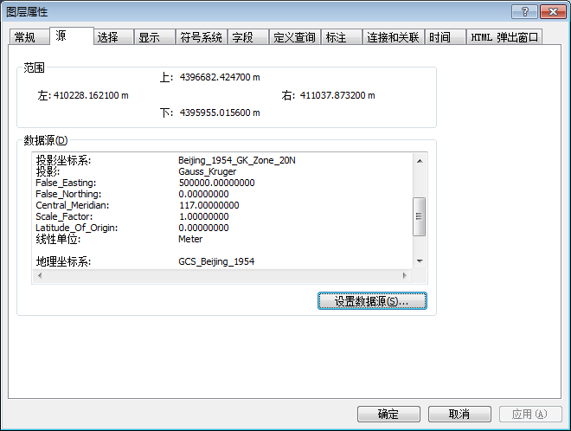

取得范围：
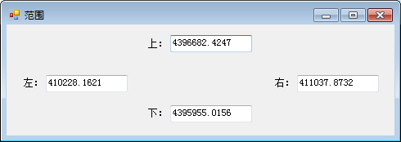
代码：
private void 获取范围ToolStripMenuItem_Click(object sender, EventArgs e)
{
ILayer pLayer = this.axMapControl1.get_Layer(0);
IFeatureLayer pFeatureLayer = pLayer as IFeatureLayer;
IEnvelope pEnvelope = ((IGeoDataset)pFeatureLayer.FeatureClass).Extent;
Form2 form2=new Form2();
form2.textBox1.Text = pEnvelope.XMin.ToString();//左
form2.textBox2.Text = pEnvelope.XMax.ToString();//右
form2.textBox3.Text = pEnvelope.YMax.ToString();//上
form2.textBox4.Text = pEnvelope.YMin.ToString();//下
form2.Show();
}

获取投影：
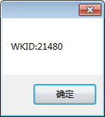 21480 Beijing_1954_GK_Zone_20N
代码：
private void 获取投影ToolStripMenuItem_Click(object sender, EventArgs e)
{
ILayer pLayer = this.axMapControl1.get_Layer(0);
IFeatureLayer pFeatureLayer = pLayer as IFeatureLayer;
ISpatialReference pSpatialReference = ((IGeoDataset)pFeatureLayer.FeatureClass).SpatialReference;
MessageBox.Show("WKID:"+pSpatialReference.FactoryCode.ToString());
}

